There are several mechanisms scammers use to hack your bank, email, or other online accounts. Please take some extra time and assess the email you have received before you reply or take action. Please be aware of the following :

- Whenever you are requested to provide your details or details about any online portal, please check whether the email originates from a proper source. This can be found in the sender’s email address. (Eg. Emails may appear to come from one of your known contacts)
- There have been many attempts by scammers initiated through email. The email may appear to be sent from any Senior Administrators of the University (Chancellor, VC, Dean, etc.) requesting some help or a reply to the email. Please check the originating email ID before you respond to such emails.
- Online portals, which include banks, Government organisations, etc., do not request personal details over email. They will always request that you do the process only through their online portal.
- There have been reports from users receiving emails with attachments regarding ‘Pending Invoices’, ‘Pending Payment’, ‘Tax Refund’, ‘Order Confirmation’, etc. Please be aware that most of these emails are fake. Please verify the sender’s address before you open the attachments in these emails.
- Be careful while connecting to online portals through a link that is received over an email. The link may be redirected to a different site, not the actual one. Hence, always check the address bar and ensure the URL is correct.
- You can ensure the website is legitimate by looking at the address bar in your browser. All connections must be in ‘https’ mode, and a ‘Padlock’ sign will appear on the address bar. You can see details on the security certificate by clicking the ‘Padlock’ icon. The security certificate will let you know to whom the security certificate is issued.
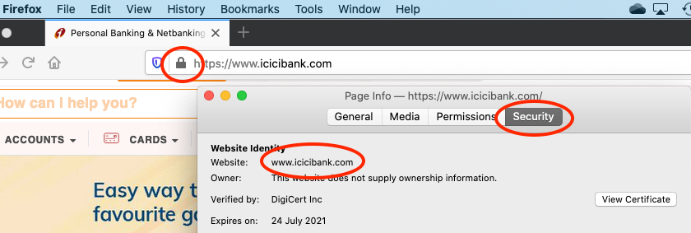
- Also, please check for the correct spelling of URLs and Email IDs. (Eg. amrita.edu spelt as amirta.edu, facebook.com spelt as facebouk.com, sbionline.com spelt as sb1online.com, etc.)
- Most of the emails received on behalf of ICTS, with sender names such as “IT Support”, “Tech Support”, “Amrita IT Support”, etc., could be spam. ICTS will NOT request your details or login credentials at any time. A link to a webpage on the campus intranet site will support all legitimate requests from ICTS. You can verify the information's authenticity by going to the intranet site.
- You may also receive emails from any compromised account in our domain. Please do not respond to any requests, click on links or open attachments which look suspicious.
- Do not install any software received as an attachment over email.
- Please don't open an attachment received over an email from an unknown source/email ID.
- If you receive a suspicious email from a known source or person, it is always good to contact the person through other means of communication and confirm the email received. This is necessary because the sender’s email might have been hacked, and the scammer may be sending emails on her/his behalf.
- Please do not initiate financial transactions based on an email/SMS/Text communication. Confirm with the person to whom you are transferring the funds to. The request may be from a scammer impersonating someone you know.

